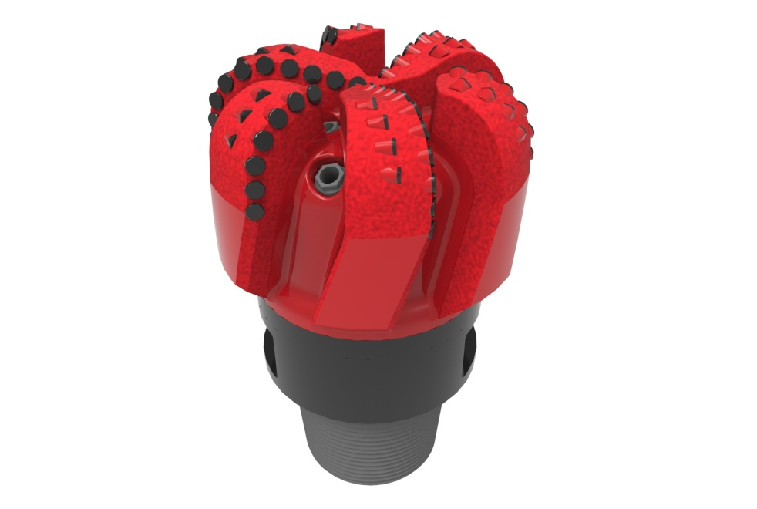
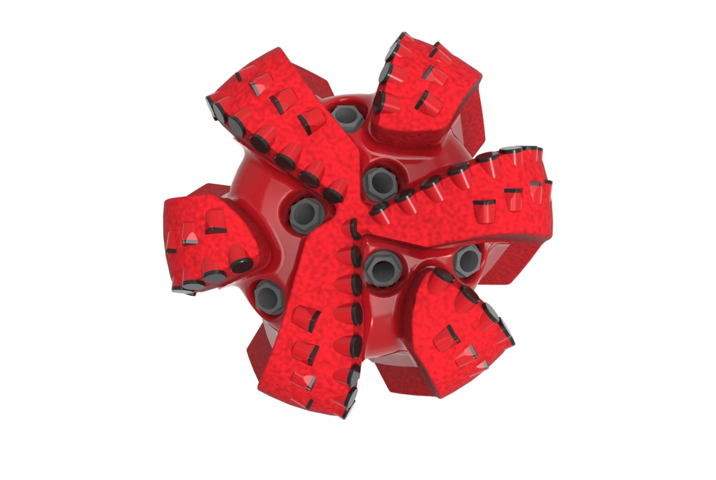

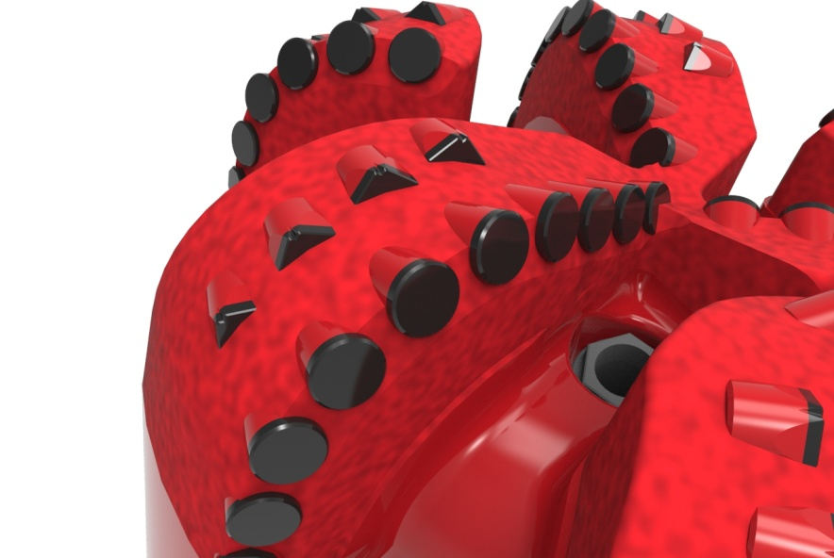

Drill Bit Specifications:
Cutter Size (Primary, Sec) | 1/2”
Cutter Count (Total, Gage, Back Ream) | 66, 6
Blade Count | 6
Gage Length (Inches) | 3.00
Nozzle Count (Primary, Sec.) | 6
Nozzle Series (Primary, Sec.) | 60
JSA (Sq. Inches) | 17.443
Max. TFA (Sq. Inches) | 2.28
Operating Parameters:
Max. Weight on Bit (1,000 Lbs.) | 60
Make-up Torque (ft/lbs) | 40,563
Nominal Dimensions:
Overall Length (Inches) | *15.87
Make Up Length (Inches) | *10.99
Bit Breaker | SKB-21011
Connection | Ø6-5/8" API Reg.
Approx. Weight (Lbs.)  *Long tool joint available upon request (adds 6” to fishing neck, makeup and overall length, and 64 lbs. to approximate weight). | *155

Taylor-Made Features:

- Premium grade cutters maximize ROP and Life
- Selectively positioned bullets for smooth drilling
- Nozzle configuration and large open face volume optimize blade cleaning and cuttings removal

613-YR Nomenclature Explained:

• | 6 | = | Number of Blades
• | 13 | = | Primary Cutter Size (13mm)
• | YR | = | Backup Cutters


